**AWS Task-5**

**Task Description:**

Deploy a simple web application using AWS code commit, code build and deploy & access via browser and automate via codepipeline.

Committed my sample web application in GITHUB  
  
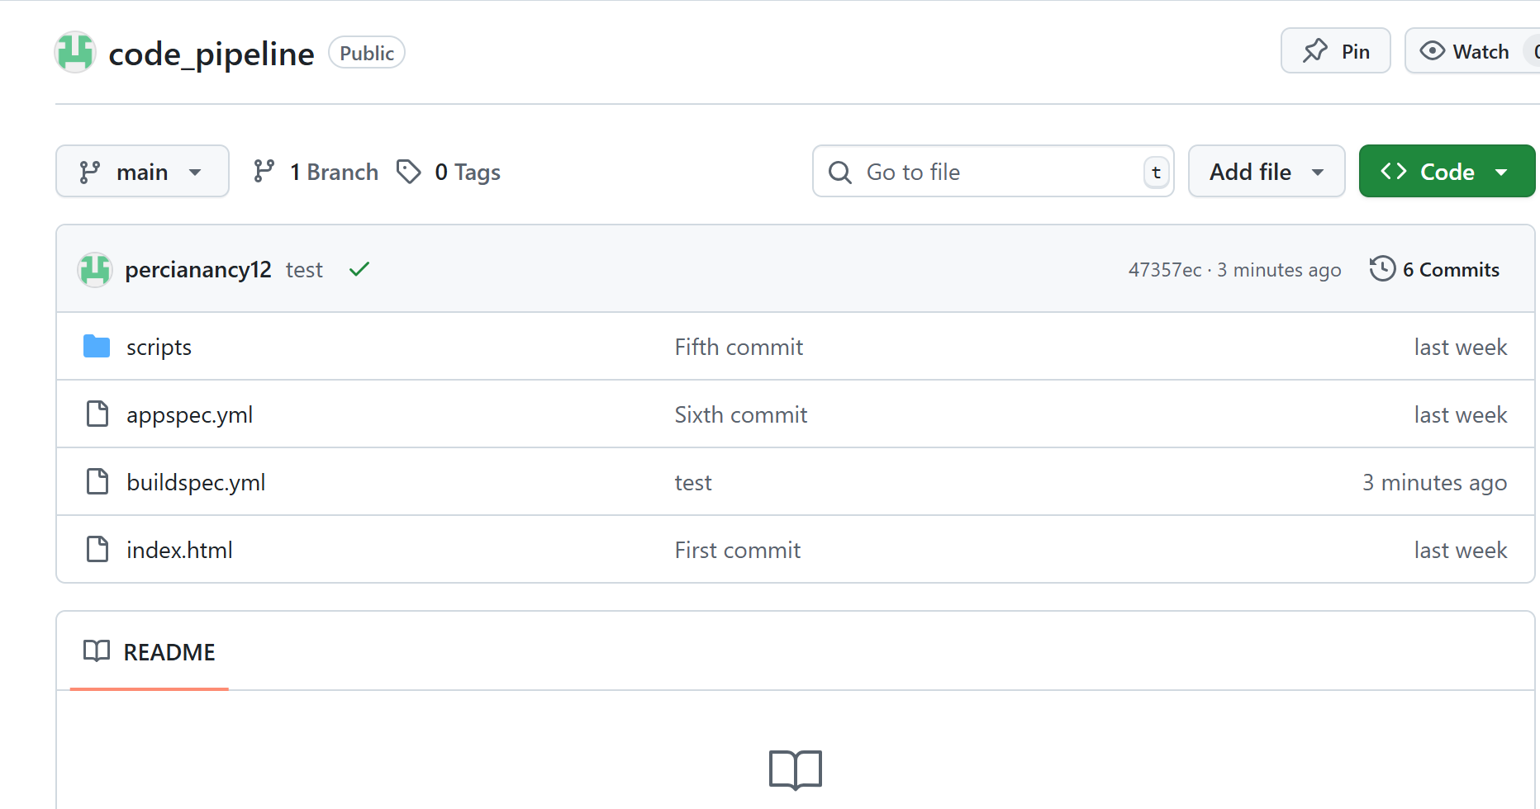

**Set Up EC2 Instance for Deployment**

* Launch an Amazon Linux 2 EC2 instance.
* Install and start Apache:

Bash commands to install Apache

|  |
| --- |
| sudo yum update -y  sudo yum install -y httpd  sudo systemctl start httpd  sudo systemctl enable httpd |

Install Code Deploy agent

|  |
| --- |
| sudo yum install -y ruby  cd /home/ec2-user  wget https://aws-codedeploy-us-east-1.s3.us-east-1.amazonaws.com/latest/install  chmod +x ./install  sudo ./install auto  sudo service codedeploy-agent start |

**Create IAM Roles**

EC2 Instance Role

Attach a role with:

* AmazonEC2RoleforAWSCodeDeploy
* AmazonS3ReadOnlyAccess

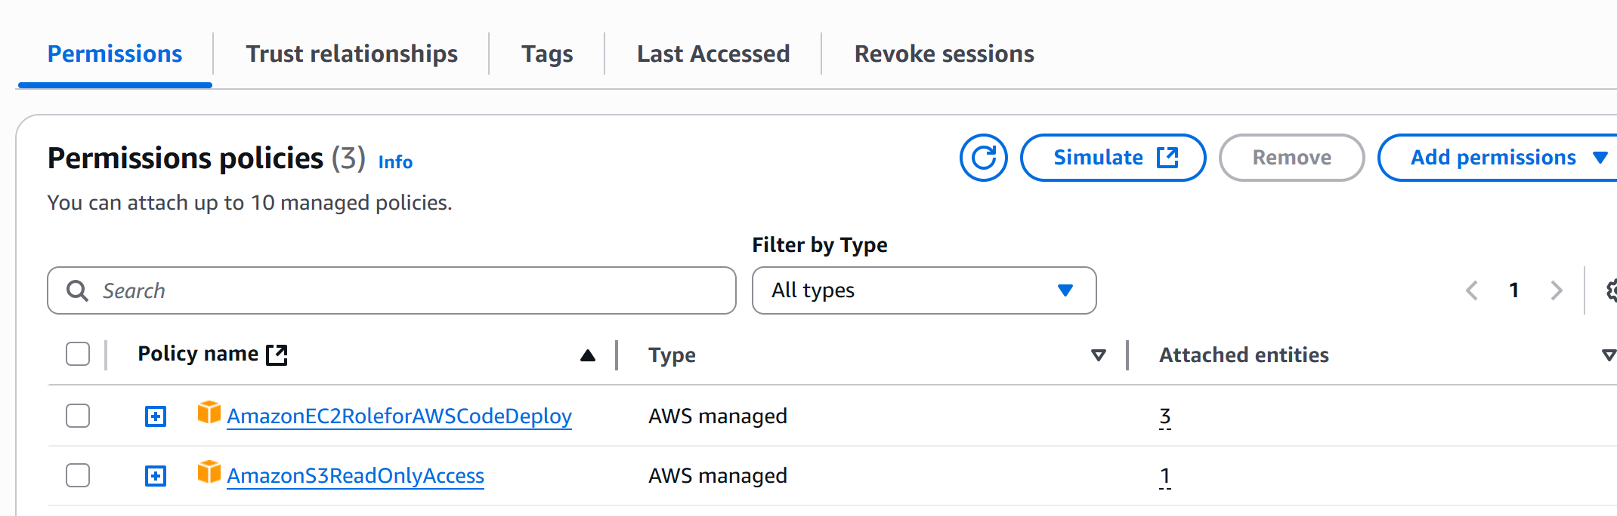

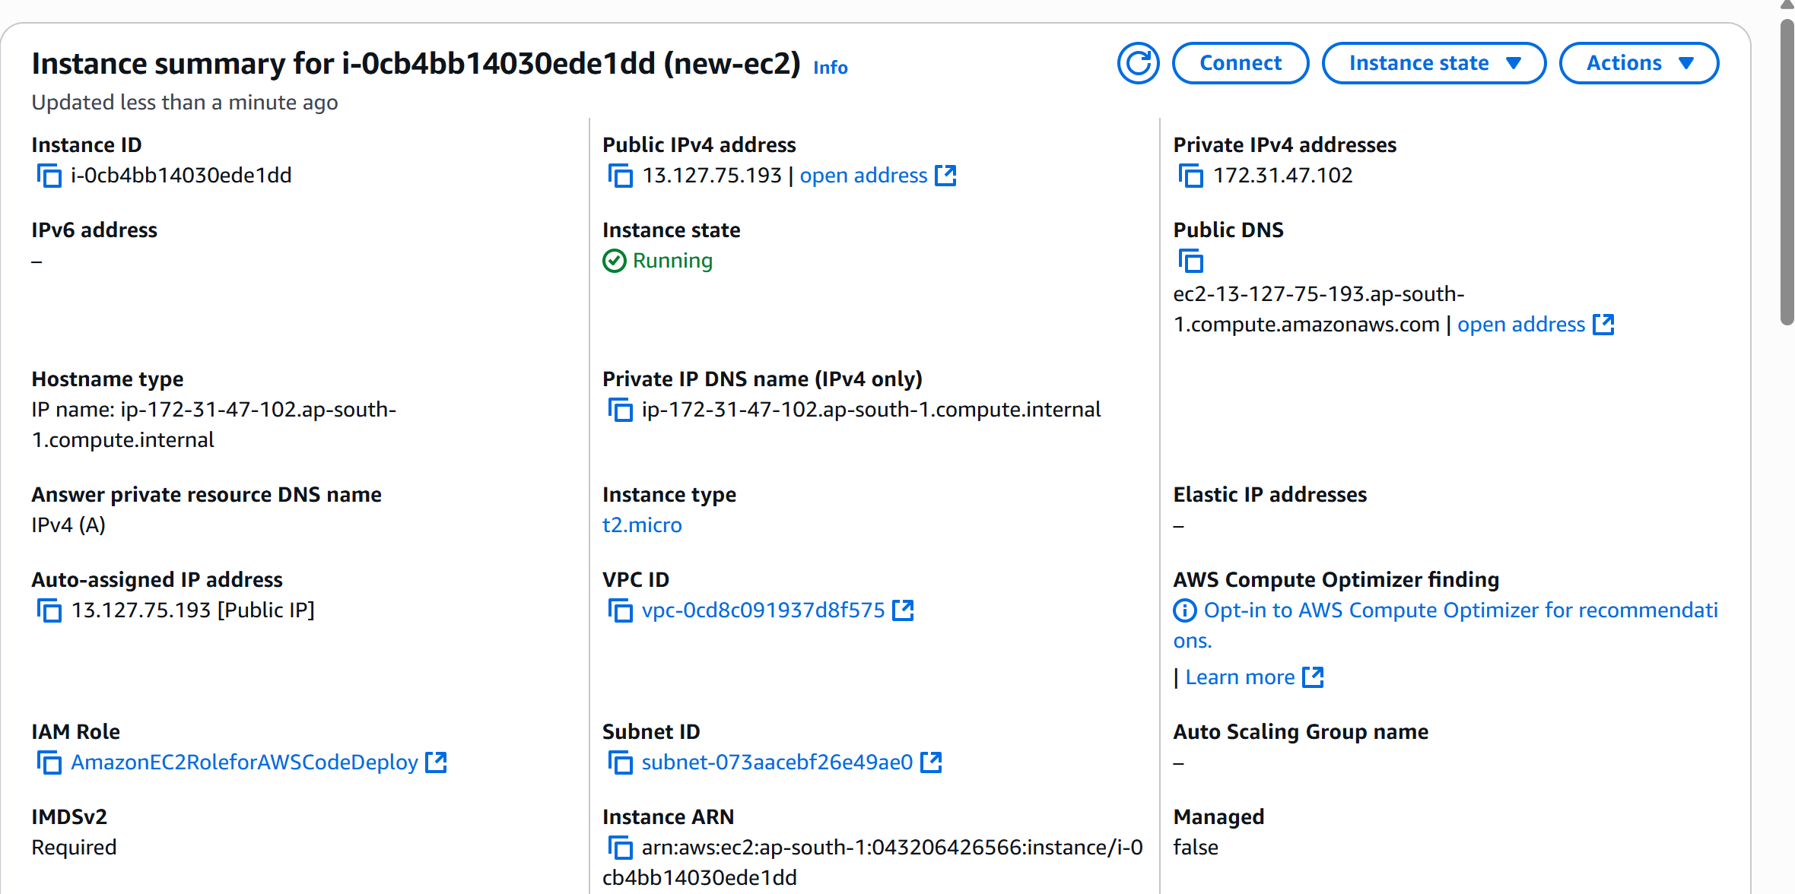

**Set Up CodeBuild**

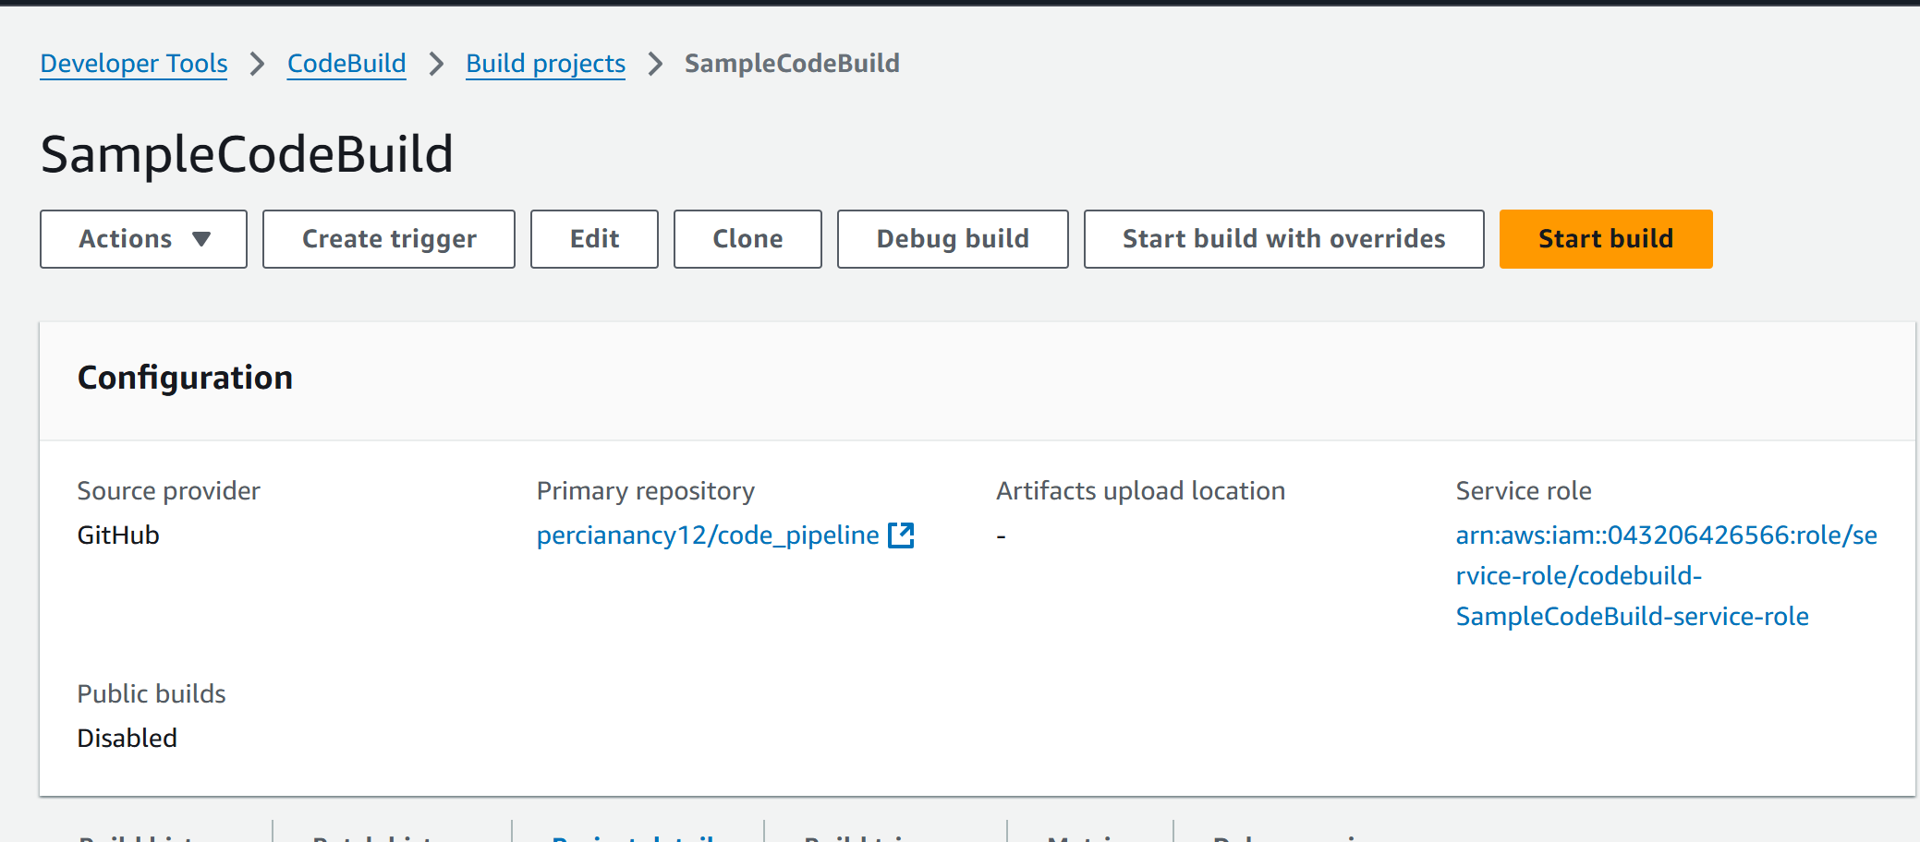

**Set Up CodeDeploy**

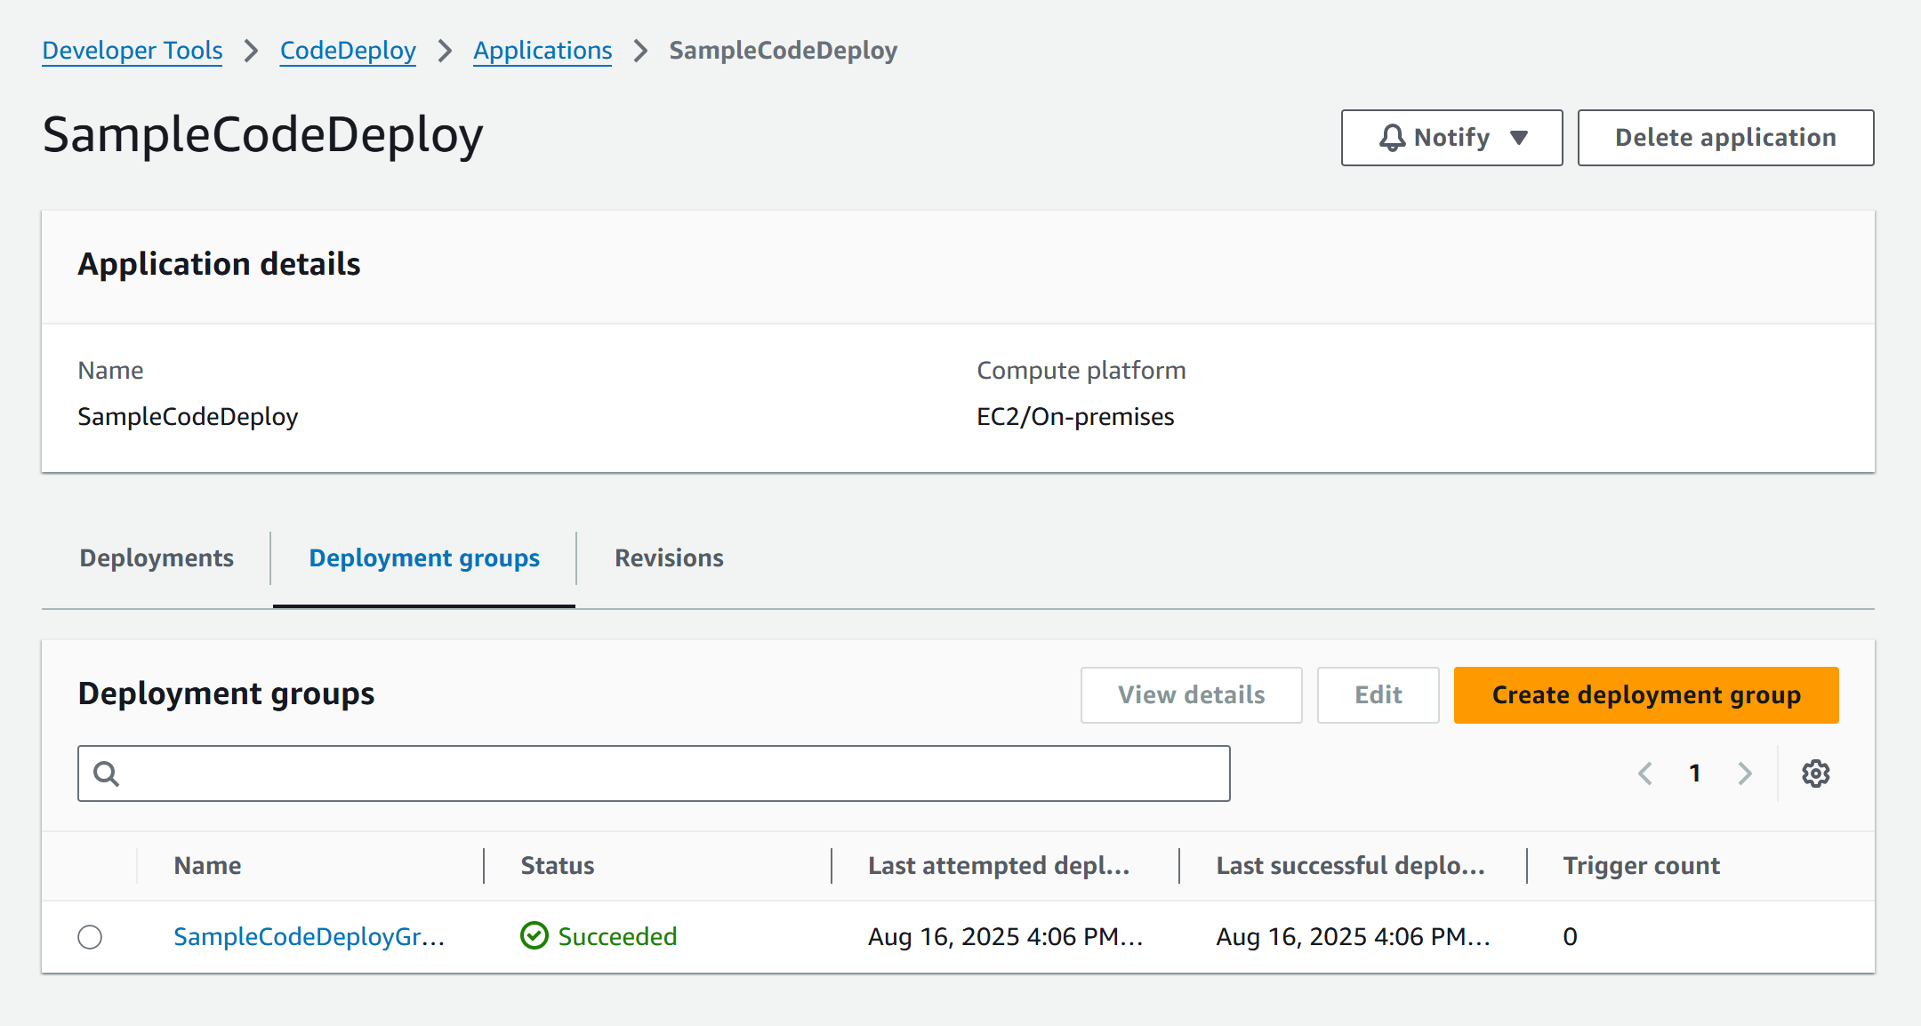

**Deployment group:**

EC2/On-premises

Select your EC2 instance using tags or manually (Add the same tag in EC2 instance as well)

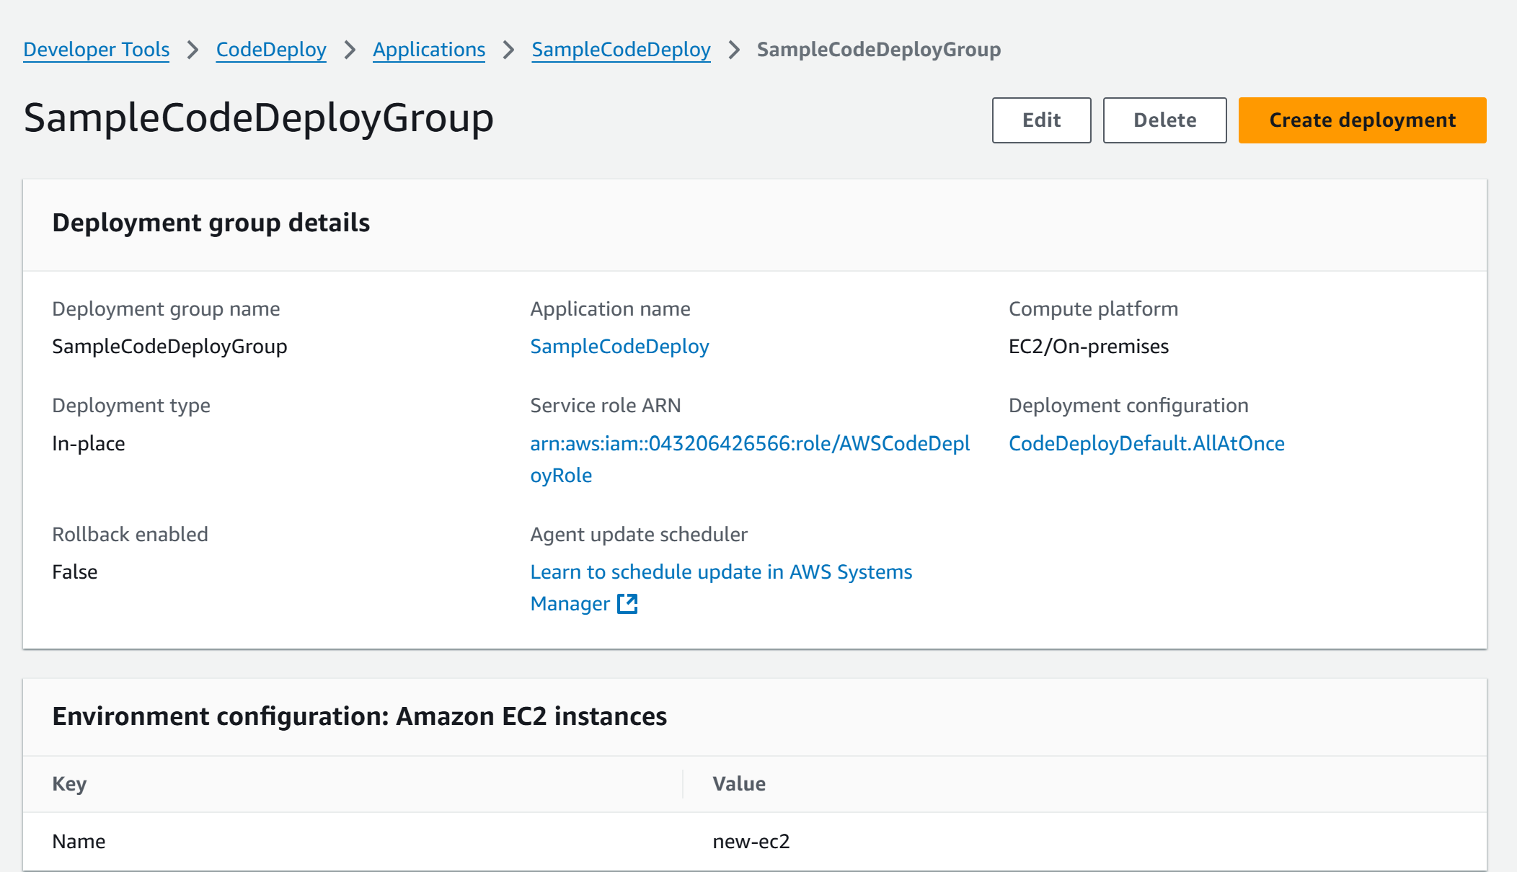

**Set Up Code Pipeline**

**Source**: GitHub source code

**Build**: CodeBuild project – newly created build project

**Deploy**: CodeDeploy application – newly created deploy application

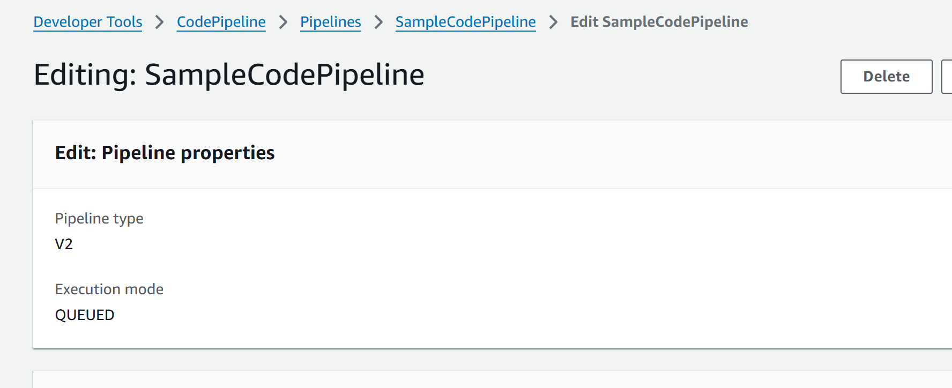

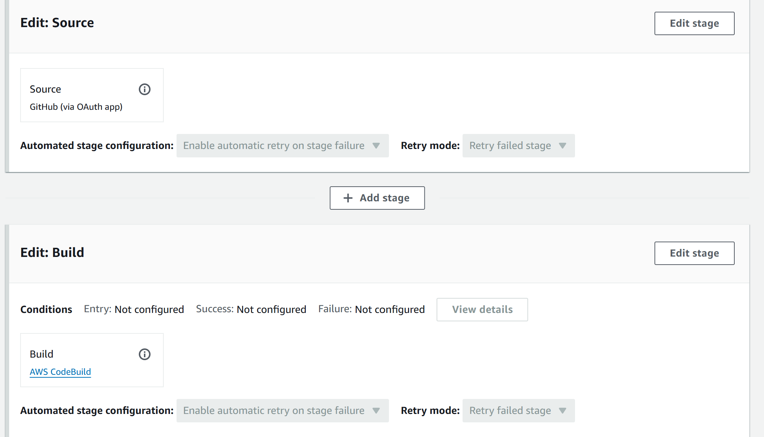

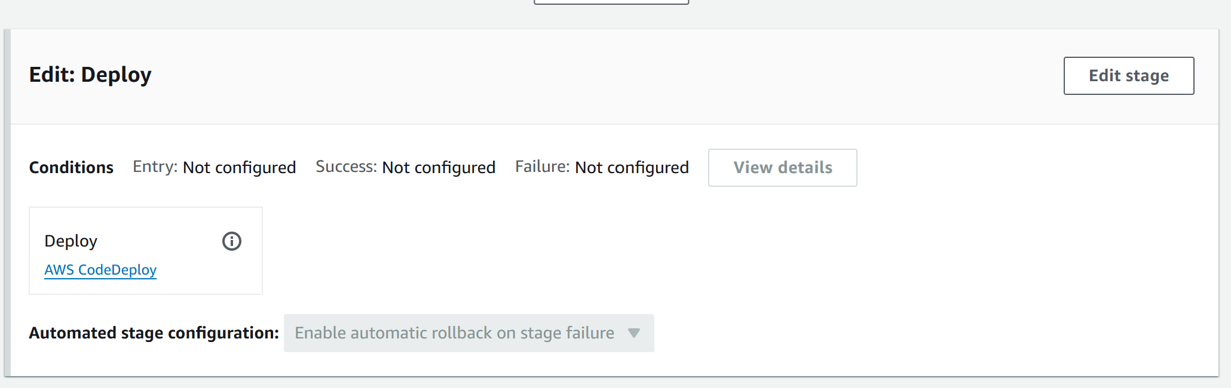

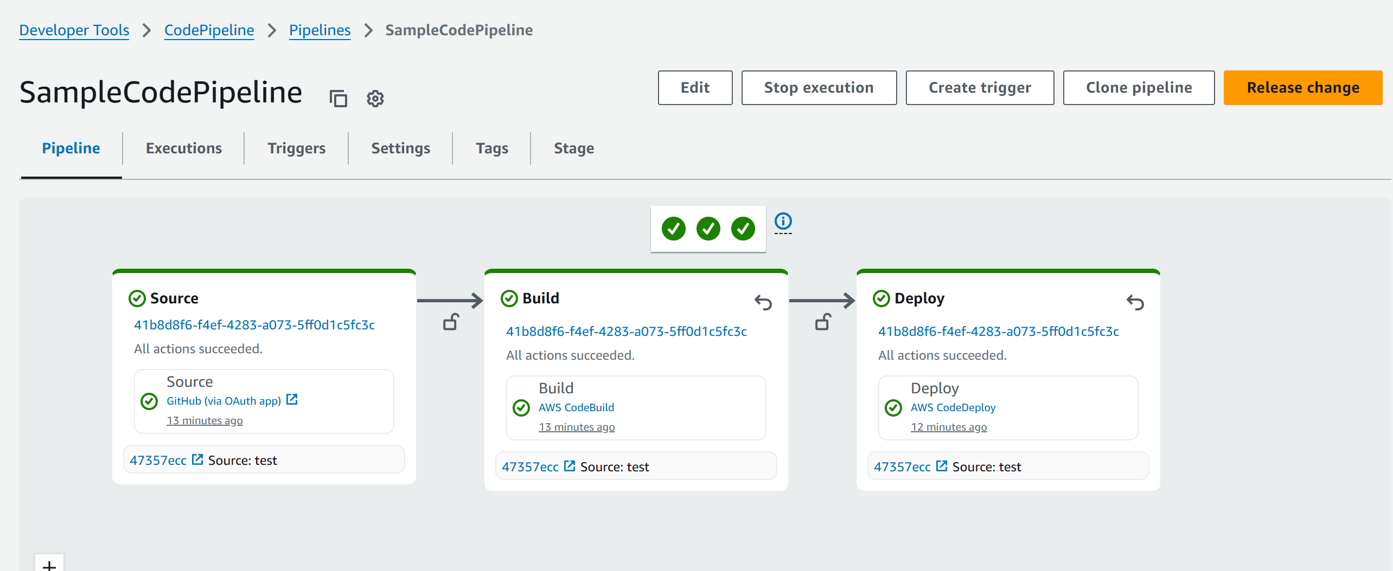

Build and Deployment succeed  
  
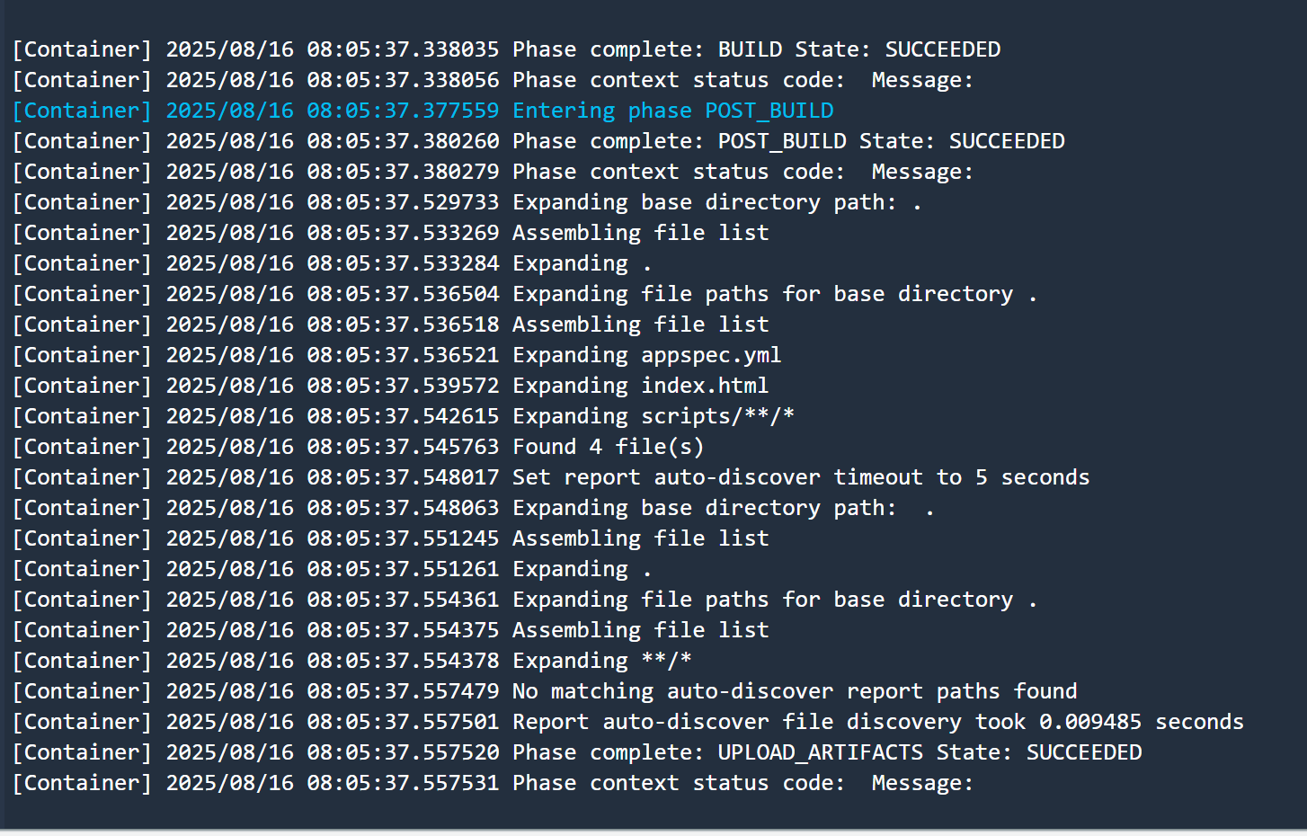

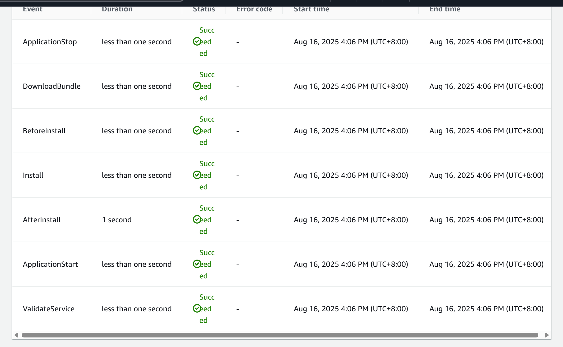

we can view the logs in EC2

sudo tail -n 50 /var/log/aws/codedeploy-agent/codedeploy-agent.log

If it succeeds, then visit the EC2 public IP in browser  
  
